Practical : 11

## Aim: Develop a web page to implement the concept of state management using Cookies.

WebForm1.aspx

<%@ Page Language="vb" AutoEventWireup="false" CodeBehind="WebForm1.aspx.vb" Inherits="Practical_11.WebForm1" %>

<!DOCTYPE html PUBLIC "-//W3C//DTD XHTML 1.0 Transitional//EN" "http://www.w3.org/TR/xhtml1/DTD/xhtml1-transitional.dtd">

<html xmlns="http://www.w3.org/1999/xhtml">

<head runat="server">

<title></title>

</head>

<body>

<form id="form1" runat="server">

<div>

<asp:Button ID="btn1" runat="server" Text="Write to Cookies" />

</div>

</form>

</body>

</html>

WebForm1.aspx.vb

Public Class WebForm1

Inherits System.Web.UI.Page

Protected Sub Page_Load(ByVal sender As Object, ByVal e As System.EventArgs) Handles Me.Load

End Sub

Protected Sub btn1_Click(ByVal sender As Object, ByVal e As EventArgs) Handles btn1.Click

Dim ck As New HttpCookie("MyCookie")

ck.Values.Add("Username", "Ishan")

ck.Expires = Now.AddMonths(2)

Response.Cookies.Add(ck)

Response.Redirect("WebForm2.aspx")

End Sub

End Class

WebForm2.aspx.vb

Public Class WebForm2

Inherits System.Web.UI.Page

Protected Sub Page_Load(ByVal sender As Object, ByVal e As System.EventArgs) Handles Me.Load

Response.Write("Welcome " & Request.Cookies("myCookie").Values("Username"))

End Sub

End Class

Output :

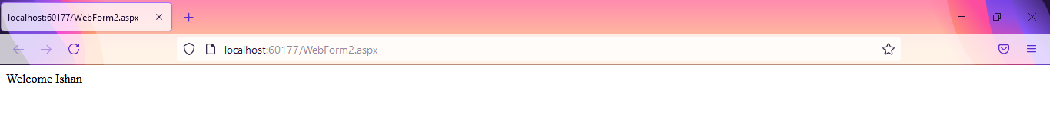

|  |  |  |  |
| --- | --- | --- | --- |
| Start Date | End/Sign Date | Faculty Sign | Remarks/Grade |
|  |  |  |  |

Practical : 13

## Aim: Develop a web page to implement the concept of state management using ViewState and QueryString.

First.aspx

<%@ Page Language="vb" AutoEventWireup="false" CodeBehind="First.aspx.vb" Inherits="Practical_13.First" %>

<!DOCTYPE html PUBLIC "-//W3C//DTD XHTML 1.0 Transitional//EN" "http://www.w3.org/TR/xhtml1/DTD/xhtml1-transitional.dtd">

<html xmlns="http://www.w3.org/1999/xhtml">

<head runat="server">

<title></title>

</head>

<body>

<form id="form1" runat="server">

<div>

First Name

<asp:TextBox ID="tb1" runat="server" />

&nbsp;

Last Name

<asp:TextBox ID="tb2" runat="server" />

<br />

<br />

<asp:Button ID="btn" runat="server" Text="Click Me" />

<br />

<a href="Second.aspx?word1=abcd...&word2=xyz">Click Here</a>

<br />

<asp:HyperLink ID="hl1" runat="server" NavigateUrl="~/Second.aspx?word1=Baburao&word2=Apte" Text="FullName Here" />

</div>

</form>

</body>

</html>

First.aspx.vb

Public Class First

Inherits System.Web.UI.Page

Protected Sub Page_Load(ByVal sender As Object, ByVal e As System.EventArgs) Handles Me.Load

End Sub

Protected Sub btn_Click(ByVal sender As Object, ByVal e As EventArgs) Handles btn.Click

Response.Redirect("Second.aspx?word1=" & tb1.Text & "&word2=" & tb2.Text)

End Sub

End Class

Second.aspx

<%@ Page Language="vb" AutoEventWireup="false" CodeBehind="Second.aspx.vb" Inherits="Practical_13.Second" %>

<!DOCTYPE html PUBLIC "-//W3C//DTD XHTML 1.0 Transitional//EN" "http://www.w3.org/TR/xhtml1/DTD/xhtml1-transitional.dtd">

<html xmlns="http://www.w3.org/1999/xhtml">

<head runat="server">

<title></title>

</head>

<body>

<form id="form1" runat="server">

<div>

Welcome To Home Page.

</div>

</form>

</body>

</html>

Second.aspx.vb

Public Class Second

Inherits System.Web.UI.Page

Protected Sub Page_Load(ByVal sender As Object, ByVal e As System.EventArgs) Handles Me.Load

Response.Write("Welcome, " & Request.QueryString("word1"))

Response.Write(" " & Request.QueryString("word2"))

End Sub

End Class

Output :

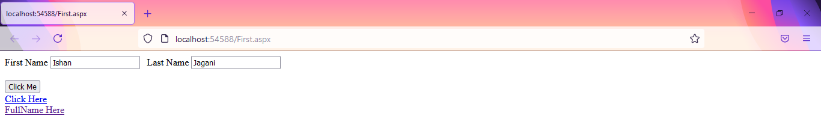

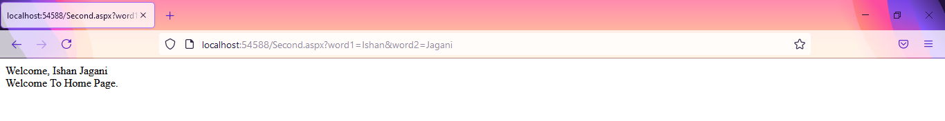

Using a tag :

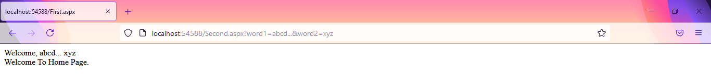

Using HyperLink tag :

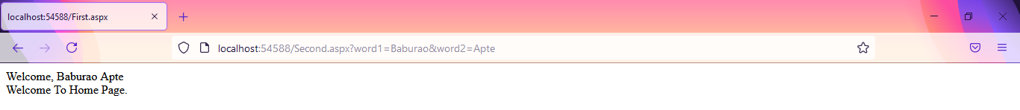

|  |  |  |  |
| --- | --- | --- | --- |
| Start Date | End/Sign Date | Faculty Sign | Remarks/Grade |
|  |  |  |  |